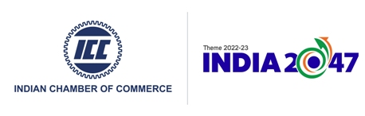 

**National Pension System (NPS) for Corporates**

**“Foundation for a better future”**

**Date**: August 11, 2023 I **Time**: 10.00 AM onwards

|  |  |
| --- | --- |
| **Draft Agenda** | |
| **Time** | **Activity** |
| **10.00 – 10.30 AM** | Registration with Tea & Coffee |
| **10.30 - 10.40 AM** | Welcome Address by:  **Mr. Sudhin Roy Chowdhury,** Advisor, Indian Chamber of Commerce (National BFSI Committee) |
| **10.40 – 11.10 AM** | Keynote Address by:  **Mr. A.G. Das,** Executive Director, PFRDA |
| **11.10 – 11.30 AM** | Industry Overview:  **CMA Chittaranjan Chattopadhyay**, Chairman, Banking Financial Services and Insurance Board, ICMAI |
| **11.30 – 11.50 AM** | National Pension System:  **Mr. Sumit Kumar,** Chief General Manager, PFRDA |
| **11.50 – 12.10 PM** | Presentation on Retirement Benefits Planning by:  **Mr. Ritobrata Sarkar,** Head-Retirement India, Willis Towers Watson |
| **12.10 – 12.30 PM** | Taxation & its’ implications:  **Senior Representative from** Deloitte Haskins & Sells LLP |
| **12.30 – 12.50 PM** | Open Session for Questions and Answers |
| **12.50 – 01.00 PM** | Vote of Thanks by:  **Mr. Alok K Chattopadhyay,** DD & advisor (F & Admin), ICC |
| **01.00 PM onwards** | Networking Lunch |

************************