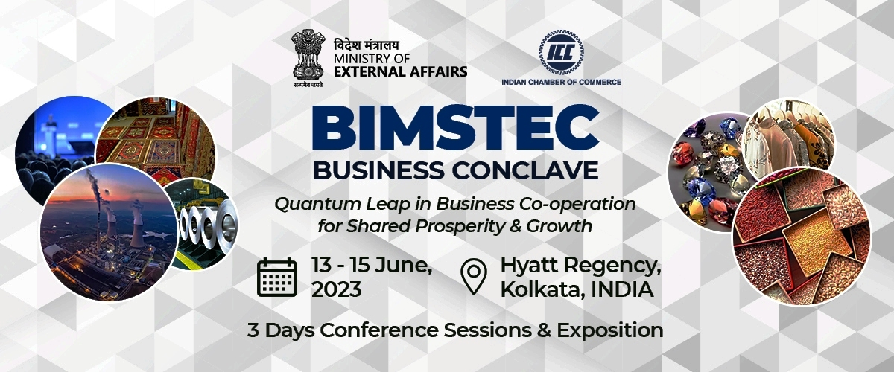

**BIMSTEC Education Forum**

**14th June 2023, Wednesday | 2.00 PM – 4.00 PM | Hyatt Regency, Kolkata**

|  |  |
| --- | --- |
| **2.00 pm – 4.00 pm**  **(Boardroom Session)** | ***Session Theme:* Harnessing Demographic Dividend to boost Economic Growth** |
|  | ***Topics for Discussion:***   * Education as the bridge of co-operation between the BIMSTEC member countries * Transformative role of Academic Collaboration in enhancing person-to-person contact, as well as more constructive regional links * Educational ties (Knowledge Sharing through Faculty & Student Exchange Programs; Business Networking through Office for International Affairs & Alumni Connect Cells) for Sustainable Development & Cultural Reconnection   ***Keynote Speaker:* Prof. V. N. Rajasekharan Pillai,** Vice Chancellor, Somaiya Vidyavihar University  **Special Guest: *Mr. K Sanjay Murthy** Secretary, Department of Higher Education, Ministry of Education, Government of India  ***Moderator:* *Prof. (Dr.) Anupam Basu,** Pro Vice Chancellor, Sister Nivedita University & Former Director, NIT, Durgapur  ***Panelists :***   * **\*Prof. Sampath Amaratunge,** Chairman, University Grants Commission - Sri Lanka * **Prof. G. D. Sharma,** Vice President, AIU & Vice Chancellor, University of Science & Technology, Meghalaya * **Prof. S. P. Singh,** Vice Chancellor, Royal Global University, Assam (verbally confirmed) * **\*Dr. Vidya Yeravdekar ,** Principal Director, Symbiosis Society & Pro Chancellor, Symbiosis International University * **\*Prof. Shalini Bharat,** Director, Vice Chancellor, Tata Institute of Social Sciences (TISS) * **\*Dr. Farid A. Shobhani,** President, Bangladesh Society for Private University Academics and Professor & Director, United International University (UIU), Dhaka * **\*Dr. Abhay Sinha,** Director General, Services Export Promotion Council (SEPC) * **\*Mr. Dipyaman Sanyal,** Head- Academics & Learning, Hero Vired * Relevant Speakers from Trigyn Technologies/ TCSiON/ Adobe/ Cisco |
|  | Question & Answer Session |