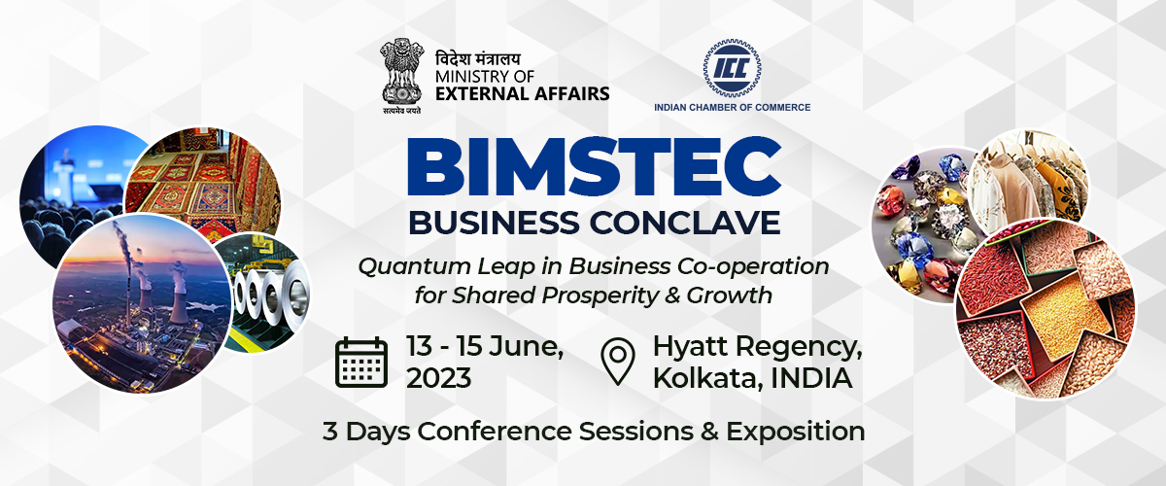

Concurrent Session

**“BIMSTEC Climate Change Forum: Challenges & Mitigation – the Policy Perspective”**

15th June 2023; 10.15 am – 12.15 pm

Program Agenda

|  |
| --- |
| Climate change is a global emergency that goes beyond national borders. From shifting weather patterns that threaten food production, to rising sea levels that increase the risk of catastrophic flooding, the impacts of climate change are global in scope and unprecedented in scale. Without drastic action today, adapting to these impacts in the future will be more difficult and costly. BIMSTEC member nations are articulating climate action plans to cut emissions and adapt to climate impacts through national policy commitments. The Asia- Pacific region is more vulnerable to climate change risks than other parts of the world, because of its dependence on the natural resources and agriculture sector, densely populated coastal areas, weak institutions, and poverty among a considerable proportion of the population. This session aims to discuss on the policy and implementation level challenges for meeting SDG goals on climate change for BIMSTEC and the scope for intra-regional cooperation in environment and climate change. |
| **Opening Remarks (1015 Hrs – 1020 Hrs):**   * **Mr. Sudipta Mukherjee**, Chief Advisor (Generation) – CESC Limited   **Panel Moderator:**   * **Mr. Ajeya Bandopadhay**, Asia Lead – Climate Change Advisory, Manufacturing, Agribusiness & Services (MAS) - IFC (World Bank Group)   **Panelists:**  **Panel 1 (1020 Hrs – 1115 Hrs):**   * **H. E. Mr. Andalib Elias**, Deputy High Commissioner - Bangladesh Deputy High Commission, Kolkata * **Ms. Melinda Pavek**, Consul-General - US Consulate-General, Kolkata * **Mr. Md. Amin Helaly**, VP – FBCCI * **Mr. Tandy Wangchuk, President - Bhutan Chamber of Commerce & Industry**   **Panel 2 (1115 Hrs – 1210 Hrs):**   * **Dr. Naresh Tyagi**, Chief Sustainability Officer - Aditya Birla Fashion and Retail Ltd. * **Mr. Somesh Biswas**, Chief Sales Planning & Administration, Long Product Marketing & Sales - Tata Steel * **Dr. Amit Kumar Thakur**, Associate Director & Head-CSR - The Energy & Resources Institute (TERI) * **Mr. Saikat Basu**, CEO – Consultivo * **Prof. Sudipta De**, Professor (Mechanical Engineering) – Jadavpur University   **Vote of Thanks (1210 Hrs – 1215 Hrs):**   * **Mr. Saikat Basu**, CEO – Consultivo |