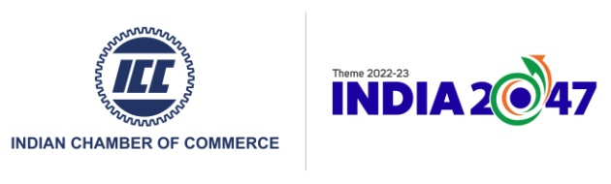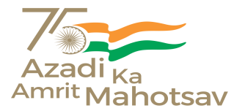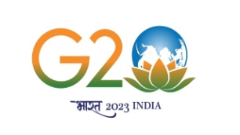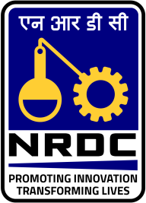

**SEMINAR CUM NRDC INDUSTRY INTERACTION MEET ON TECNOLOGY TRANSFER OPPROTUNITIES IN AGRICULTURE, TEA & FOOD PROCESSING TECHNOLOGIES**

**25th January'23, 10.00 AM at Hotel Paramount Palacio (Harmony Banquet), Guwahati, Assam, India**

REGISTRATION FORM

**We would like to participate. The following Participant / Participants will attend the Conference:**

|  |  |  |  |  |  |
| --- | --- | --- | --- | --- | --- |
| **Sl.No.** | **Name** | **Designation** | **Organisation** | **Mobile No** | **Email** |
| 1. |  |  |  |  |  |
| 2. |  |  |  |  |  |
| 3. |  |  |  |  |  |
| 4. |  |  |  |  |  |
| 5. |  |  |  |  |  |

## Note: 1) Participation exclusively on the registration basis

1. **No registration fees**

**The completed registration form please emailed to:**

**Pranjit Tamuli**

Indian Chamber of Commerce

North East India Regional Office

Kushan Plaza, 1st Floor, Ganeshguri, G.S. Road

Guwahati – 781006, Assam

**Mobile:** +91-9508567895

**Email:** [pranjit.tamuli@indianchamber.net](mailto:pranjit.tamuli@indianchamber.net)