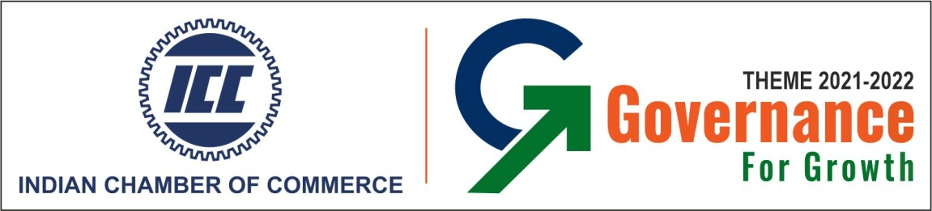

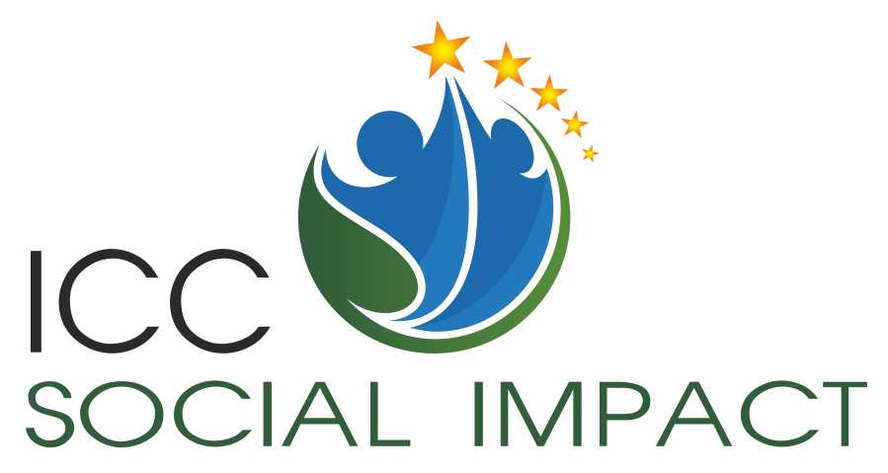

5th ICC Social Impact Award 2023

Application Guideline

Knowledge Partner:

About the Award
Indian Chamber of commerce (ICC) is an eminent consortium of business organizations in eastern & north-eastern India. Several large corporate groups in the country and overseas are affiliated to this organization.

The Indian Chamber of Commerce (ICC) is one of the most pro-active and forward-looking Chambers with its membership spanning across some of the most prominent and major industrial groups in India. ICC’s forte is its ability to anticipate the needs of the future, respond to challenges, and prepare the stakeholders in the economy to benefit from these changes and opportunities.

Corporate Sustainability and Responsibility is a strategic initiative to sustain the business in highly competitive environment. CSR enhances reputation, builds positive bridges to communities, benefits customers and public at large and in doing so affects people, planet and profit.

The ICC SOCIAL IMPACT Awards is an initiative of ICC through which the Chamber would engage with corporate, NGOs and Implementing Agencies in order to recognize and encourage them for exemplary work done in their respective fields of operation at a pan India basis. ICC announces ‘Social Impact Award 2023’ to recognize the excellence of organizations in the sphere of social investment, CSR and sustainability for the year 2020 - 2021.
Consultivo Business Solutions Pvt. Ltd. (Consultivo), is the knowledge partner and provides the framework and relevant technical support for the award. Consultivo is a sustainability advisory firm involved in audit, training, research and consulting.

Objective of the Award:
The purpose of this award is to evaluate an organization’s concern towards the well-being of the society through adequate measures, not only for regulatory requirements, but also as a part of the management’s commitment towards ensuring that the people are adequately being taken care of.
The aim of the award is to recognize the best CSR initiatives. The award encourages the organizations on social projects and programmes and increases the recognition of Corporate Social Responsibility Principles in their operations.

The main objectives are to:
- Identify and recognize the exemplary CSR performance / projects / programmes
- Given visibility to CSR excellence and raise awareness on the positive impact that business can have on society
- Bring the best CSR multi stakeholder projects in to focus
- Enhance the exchange of best CSR practices across India
- Encourage CSR collaboration between business and stakeholder
- Motivate companies, CSR foundations and implementing partners to deliver high impact CSR projects through collaborative approach

Eligibility Criteria
All Indian organisations are eligible to apply for the Award.

Applications are invited for the following two types of entities:
- Corporate CSR Wing including PSUs
- Implementation agency / NGO / Trust / Civil society organizations/Institution

Who can apply

Corporate CSR Wing including PSUs |  |  | Implementation agency / NGO / Trust / Civil society organizations
Mega Enterprise | With turnover more than 5000 crore |  | Large Project | Projects more than 10.0 crores
Large Enterprise | With turnover between 1000 – 5000 Crore |  | Medium Project | Project size between Rs. 2.0 -10.0 Crores
Small and medium enterprise | Upto 1000 crore |  | Small | Projects size between 50.0 lakhs and 2.0 crores

Note:

- Organizations are requested to submit their audited balance sheet of the year 2020-2022 if selected for the final round presentation.
- The Small & Medium scale organizations are requested to provide their MSME Registration number.
- Organisations may declare a particular requirement as ‘Not Applicable’ depending on their activities (Service or Manufacturing). However, a brief explanation will be appreciated.

Award category

Open for Corporate CSR Wing / Implementation Agency / NGOs & Trusts - One Award for each category in each of the areas listed below

- Promoting Education
- Clean Energy
- Environment Sustainability
- Healthcare
- Eradicating Hunger & Poverty
- Promoting Gender Equality & Women Empowerment
- Reducing Child Mortality & Improving Maternal Health
- Employment enhancing Vocational Skills
- Empowering the Rural population
- Clean Water & Sanitation
- Others

Award Process
Call for applications
Application entry form submission
Review and short listing. Summary of applications
Nomination of application by JuryBoard
Presentation of nominated Projects at the Social Impact Conference
Jury Selection of final award winner
Award Presentation

Evaluation Framework
Entries are judged by a panel of corporate, agency and academic executives as well as ICC and knowledge partner Consultivo. Jury committee will evaluate the entries based on creativity, innovation, planning, implementation and impactful outcome of the project. The most important bench is proven success in aligning strategic objectives with end goals.

The following parameters will be considered while evaluating the applications:
- CSR and sustainability policy and objective
- Alignment with Sustainable Development Goals or other national / international conventions, initiatives
- Scope and rationale behind the project
- Innovative aspect if any
- Implementation methodology
- Outcome of the project – impact assessment
- Calculated Social Return on Investment (SROI)
- Impact of the project with number of beneficiaries
- Sustainability of the project
- Long term impact of the project
- Project disclosure, communication and documentation
- Project learning and way forward

Award Committee
The Award Committee comprises of the following:

- Chairperson
- 3 – 5 Members comprising of eminent business leaders, management experts, Social and sustainability professionals and at least one senior sustainability professional from Consultivo.
The final decision for the award will be taken by the Award Committee. The decisions of the Committee will be final and no appeal will be entertained.

Levels of Recognition
There are two levels of recognition for each category. These levels signify the various milestones, which the organisations can aim for as they progress on their journey towards excellence. Therefore, the organisations at different level of competitiveness can benefit from participating in the award process.

Levels: A. Winner B. Runners-up

Apart from getting an opportunity for recognition, each company gets an external perspective on their practices and performance. Each Applicant Company is assessed by a team of trained assessors with diverse and extensive experience who will spend significant time to identify the strengths and opportunities for improvement for each organization.

How to Apply

General Guideline

Please read carefully the instructions before completing the application document:
- The filled in application document are required to be submitted to the ICC Award committee in soft copy.
- Each copy of the application document should not exceed 50 pages including all the supporting documents.
- Each page of the application document should be of A4 size only.
- Please include table of contents, glossary of terms and abbreviations for clarity.
- Please read each section carefully and respond to the points raised therein briefly.
- Please describe the details in English, typescript, text in Arial point 11. The pages may be numbered.

Application Fees:

The fee for processing the application is as follows:
- For Mega Enterprise - INR 30,000/- plus 18% GST for single project ; INR 45,000/- plus 18% GST for multiple projects* ( Maximum 3 Projects)
- Large Corporates: INR 25,000/- plus 18% GST for single project ; INR 40,000/- plus 18% GST for multiple projects* ( Maximum 3 Projects)
- For SME : INR 10,000 + GST for single project and INR 15,000/- + GST as applicable for multiple projects*( Maximum 3 Projects) (please include a certificate of MSME to support SSI category)
- For Implementation agency / NGO / Trust / Civil society organizations: INR 15,000/- plus 18% GST for single project; INR 20,000/- plus 18% GST for multiple projects*

*Maximum 3 projects are allowed under ‘multiple projects’.

The fee should accompany the application, in the form of a demand draft / cheque at par/NEFT, favouring “Indian Chamber of Commerce”.

Rules & Regulation:
- Decision of the Award Jury Council on the recommendations of the Jury members is final and no appeal or correspondence will be entertained.
- Award Committee reserves the right to award more than one organisation as the winner and also to withhold award(s), if the required standard is not met.
- Award Committee accepts no liability for any loss resulting from the disclosure of information concerning an entry to Assessors and Jury members, though all reasonable precautions will be taken to maintain confidentiality.
- Award Committee cannot undertake to return documents or supplementary material submitted with an entry.
- Award Committee reserves the right to alter the Award Scheme, at any time.
- Last date of submission of filled-up Application Form is15thDecember 2022

Please send the duly filled up application form with requisite supporting documents and application fee to the following address –
Ms. Soheni Laha
Indian Chamber of Commerce
4 India Exchange Place, 9th Floor
Kolkata 700001
Ph: 033 2253 4256
Email: soheni.laha@indianchamber.net

Non-Disclosure and Confidentiality
Names of applicants, examination and scoring information developed during the review of applications are regarded as proprietary and are kept confidential. Such information is available only to those individuals directly involved in the assessment and administrative processes. Award committee will take all reasonable measures to ensure that applications and information therein are treated in strict confidence. However, in no way can Award committee be held responsible for any loss of confidentiality to a third party. Moreover, Award committee cannot be held liable for any damage (to goods, or persons, financial loss or consequential) incurred through the breach of confidentiality or otherwise by the applicants or any third party. Award committee reserves the right, subsequent to the Award Presentations, to publish salient details of the Improvement schemes of the Award Winners, as a step towards sharing of knowledge.

