Organized by

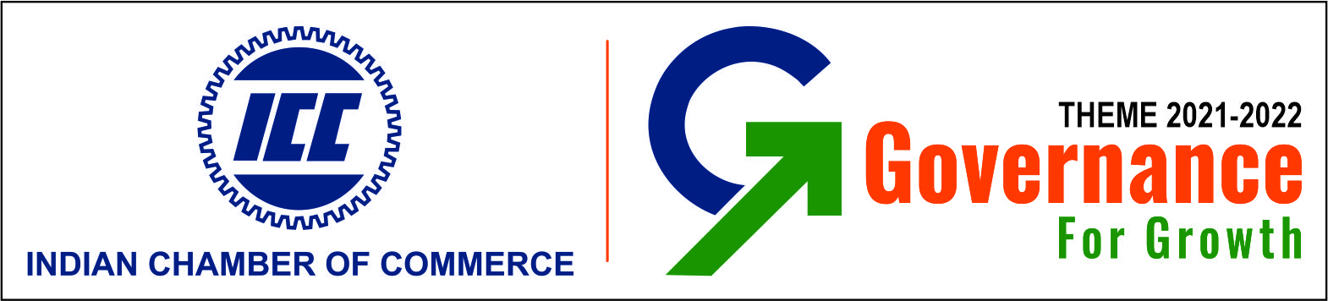

In collaboration with CSIR-CSMCRI

Marine Chemicals Conclave

(Virtual Summit)

Marine Chemical Industry Meet

27th July 2022

10:00 AM – 12:00 PM

FINAL PROGRAM SCHEDULE

10:00 - 12:00Hrs | Session
10:00Hrs | Welcome Address | Dr.Rajeev Singh  Director General  ICC
10:05Hrs | Chief Guest | Shri. Satendra Singh  Additional Secretary & Financial Advisor  Chemicals and Fertilizers  Ministry of Chemicals and Petrochemicals  Government of India
10:20Hrs | CSIR overview | Dr. S.Kannan  Director,  CSIR-CSMCRI
10:30Hrs | Salt technologies & Importance of Bittern as Feedstock for Marine Chemicals | DR. Arvind Kumar  Senior Principal Scientist  CSIR-CSMCRI
10:40Hrs | Refractory Magnesia technologies | Dr. Himanshu Shekhar Tripathi  Senior Principal Scientist& Head Refractory and Ceramics division.  CSIR-CGCRI
10:50Hrs | Magnesium Extraction through Molten Salt Electrolysis ,  CECRI's Legacy and way forward | Dr. C. Naveen Kumar,  Sr. Scientist  CSIR-CECRI
11:00Hrs | Industry Speaker –Bittern Valorisation - Issues | Mr. Bharat Raval  Vice President & Unit Head · Grasim industries ltd & President of The Indian Salt Manufacturers association.
11:10 Hrs | Industry Speaker – Potash Experience | Mr. N.H.Khan  DGM Process Development  TATA Chemicals
11:20Hrs | Industry Speaker - Refractory Magnesia | Mr. Biswajit Ghosh  Associate Vice President ( Technology)  KROSAKI Refractories Limited.
11:30 Hrs | Developmental works on magnesium metal production by fused salt electrolysis of anhydrous MgCl2. | Dr.Chaganti RVS Nagesh  Scientist G & Head,  Titanium & Magnesium Group,  DMRL, DRDO,  Kanchanbagh  Hyderabad
11:40Hrs | Q&A session
11:55rs | Concluding Remarks + VoT | Mr.Sushantjit Dey  Deputy Director  ICC

