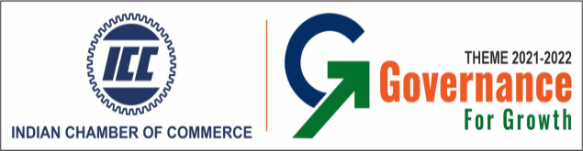

**Business Conference: Governance for Growth**

**-------------------------------------------------------------------------------------------------------------**

**6th April 2022 | 12:00 noon onwards |Hyatt Regency, Kolkata**

**Programme Schedule**

|  |  |
| --- | --- |
| 12:00pm – 12:45pm | Inaugural Session |
|  | Welcome Address:  **Mr Pradeep Sureka**  President,  Indian Chamber of Commerce |
| Address By:  **Ms. Chandrima Bhattacharya** Minister of State for Department of Finance (Independent Charge), Health & Family Welfare Department and Land and Land Reforms Department  Government of West Bengal. |
| Address By:  **Mr. Firhad Hakim**  Mayor, KMC  Minister in charge for Urban Development and Municipal Affairs, Transport& Housing Department,  Government of West Bengal. |
| Vote of Thanks:  **Mr. Nakul Himatsingka**  Chairman,  ICC National Expert Committee on Real Estate |
| 12:45pm – 01:45pm | **Urbanization & Environment Care** |
| Session Moderator:  Mr. Tamal Ghosal  President  CREDAI Howrah- Hooghly | Urbanization in regard to infrastructure, land policies, roads etc are the essentials to sustain business ecosystem that leads to development of a region. This works with considering urbanization and the significant point of Environment in order to lead to healthier living and development standards.  In this background the session will have authorities and stakeholders to discuss the Development Agenda needed to address The Urban Development front along with environmental care and Initiatives needed to be introduced or assistance in continuation with the present policies aiming at achieving enhanced pace of development at the emerging State of West Bengal along with a balanced environment. |
| Address By:  **Dr Rajesh Kumar- IPS**  Member Secretary  West Bengal Pollution Control Board |
| Address by:  **Mr. Binod Kumar, lAS**  Municipal Commissioner  KMC |
| Address by:  **Mr. Naveen Prakash, lAS(Retd)**  Principal Advisor (Infrastructure)  Government of West Bengal |
| **Mr. Nandu Belani**  President  CREDAI Bengal |
| Q & A |
| 1:45pm | **Concluding Remarks** |
|  | **Mr Harsh Jain**  Co Chair  ICC National Expert Committee on Real Estate |
| Lunch & End of Programme | |