**INDIA eCONSTRUCT EXPO**

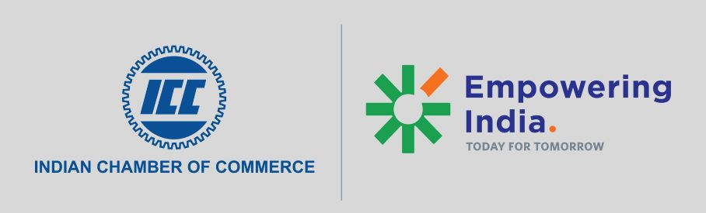

***“An Exposition & Buyer Seller Meet on Realty Construction and Construction Materials”***

**9th August, 2021**

**Tentative Programme Structure**

|  |  |  |
| --- | --- | --- |
| **03:00 PM – 04:30 PM (IST): INAUGURAL SESSION** | | |
| 15:00 IST – 15:10 IST | Welcome Address | **Mr. Pradeep Sureka**  Sr. Vice President  ICC |
| 15:10 IST – 15:25 IST | Theme Address by | **Mr. Harsh Vardhan Patodia**  National President  CREDAI India |
| 15:25 IST – 15:40 IST | Industry Perspective | **Ms Radha Dhir**  CEO  JLL India |
| 15:40 IST – 15:55 IST | Address by **“Special Guest”** on *“India-Sri Lanka Business Opportunities”* | **H.E. Gopal Baglay**  Hon’ble High Commissioner  High Commission of India, Sri Lanka |
| 15:55 IST – 16:10 IST | Address by **“Special Guest”** on *“India-Phillipines Business Opportunities”* | **H.E. Sambhu S Kumaran**  Hon’ble Ambassador  Embassy of India, Phillipines |
| 16:10 IST – 16:25 IST | Address by **“Special Guest”** on State perspective | **Mr. Manoj Kumar Meena, I.A.S.**  Secretary  Karnataka Housing Department  Government of Karnataka |
| 16:25 IST – 16:30 IST | Vote of Thanks | **ICC** |