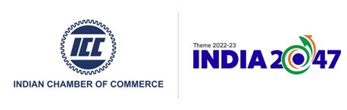
SAARC Trade Fair
31st May – 2nd June 2024; 8 am – 9 pm daily; Excel World Colombo Convention Centre, Colombo, Sri Lanka

EXHIBITOR REGISTRATION FORM
Name of the organization:
Address:
GST No:

Head of the organization: | Contact Person:
Designation: | Designation:
Phone No: | Mobile No:
Email Id: | Email Id:

Participation Options (Please tick appropriate box)
- 6 SQMTS furnished stall: INR 50,000/- +18% GST | - 9 SQMTS furnished stall: INR 60,000/- +18% GST
Payment terms:
1. 100% payment to be made within 7 days from receiving the proforma invoice.
2. Tax invoice to be issued after receiving the payment
3. All payments to be made in INR by either Demand Draft/ Cheque favouring “Indian Chamber of Commerce”, payable at Kolkata, India or through NEFT.
ICC bank details:
Payee Name: Indian Chamber of Commerce
Account Type: Current
Account Number: 00290200000821
IFSC: BARB0INDIAE (5th Character is Numeric ZERO)

Date: Signature & Company Seal

More information please contact:
Suryadeep Roy; Phone : +91 033 2253 4350 ; 90380 00994; Email : suryadeep.roy@indianchamber.net

